1 Corinthians 6:19-20: Do you not know that your body is a temple of the Holy Spirit within you, whom you have from God? You are not your own, for you were bought with a price. So glorify God in your body.

1 Corinthians 10:31: So, whether you eat or drink, or whatever you do, do all to the glory of God.

Rise & Shine Smoothie

Chocolate, Peanut Butter, Oatmeal

Total Time: 5 minutes serves: 2

INGREDIENTS:
- 1/2 cup Almond milk
- 1 Banana, frozen-optional (or use a cup of ice)
- 2 tablespoon Peanut butter
- 3 tablespoon Quick Oats
- 1 teaspoon Cocoa powder
- 1 teaspoon of Agave nectar

DIRECTIONS:
- Combine almond milk, banana, oats, cocoa powder, peanut butter & sweetener in a high-powered blender. Blend until smooth, adding additional milk as needed for desired thickness.
- Enjoy immediately or store in a sealed container in the refrigerator for up to 24 hours.

health benefits:
Almond Milk: Dairy-free; low in calories & sugar; high in calcium, vitamin E & vitamin D

Banana: High in potassium, fiber, vitamins C & B-6; easily digestible; fat & cholesterol free

Peanut Butter: High in protein; healthy fat; source of fiber; keeps you full.

Oats: Gluten-free whole grain; high in fiber & antioxidants; lowers cholesterol & blood sugar.

Cocoa Powder: High in fiber & antioxidants.

Agave Nectar: All-natural, low-glycemic sweetener; sweeter than sugar so you use less.

Banana Basic

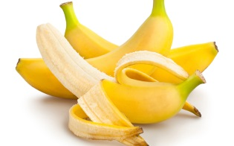
Bananas help keep your bowels healthy, provide nutrients that regulate heart rhythm and have vitamin compounds for eye health.

- 1 Cups water or Milk of choice
- 2 Bananas
- 1 cup spinach
- with or without yogurt
Fruit can be fresh or frozen. Blend and enjoy!

Strawberry Soul
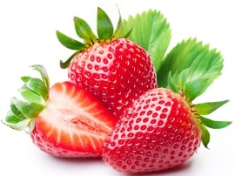

Strawberries are packed with antioxidants, lower blood pressure and protect your heart. Packed with essential vitamins and minerals, they are also sodium, cholesterol and fat free.

- 1 cup water or Milk of choice
- 1 cup strawberries
- 1 banana
- 1 cup spinach
- with or without yogurt
Fruit can be fresh, frozen or canned. Blend and enjoy!

