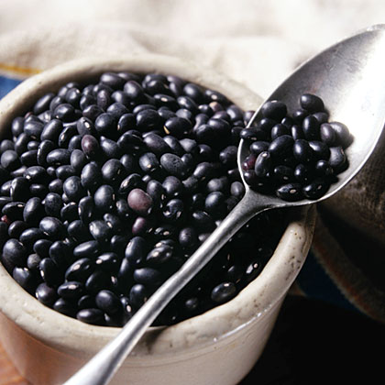

Once you go Black Bean…
The black bean is a small, shiny variety of common beans, especially popular in Latin American cuisine, though it can also be found in Cajun and Creole cuisines of south Louisiana.
The black bean's fiber, potassium, folate, vitamin B6 and phytonutrient content, coupled with its lack of cholesterol, all support heart health. The fiber in black beans helps lower the total amount of cholesterol in the blood and decrease the risk of heart disease.
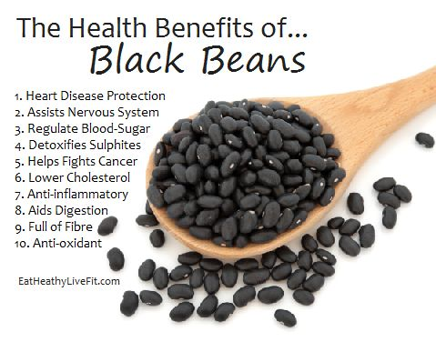

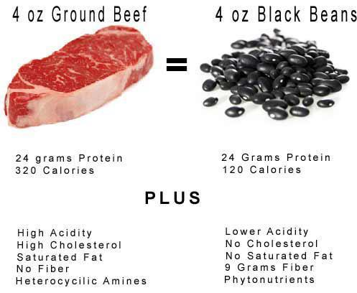

Black Bean Burger Recipe
2 cups cooked black beans (about 2 15-ounce cans), drained & rinsed
1¼ teaspoons garlic powder
1 teaspoon chili powder
1 teaspoon cumin
½ teaspoon ground paprika
½ teaspoon salt
2 teaspoons finely chopped cilantro
Pinch of turmeric (optional)
¼ cup green peppers, finely chopped
½ cup bread crumbs or oats (gluten-free also an option)
½ cup red onion, finely chopped
1 large carrot, grated
1 egg or 1 flax egg (see the note)
Instructions
- In a large mixing bowl, mash 1½ cups of the black beans. Add remaining ½ cup of beans.
- In a small bowl, mix together the garlic powder, chili powder, cumin, paprika, salt, cilantro, and turmeric (if using).
- Pour the spices over the bean mixture.
- Add all of the remaining ingredients, and mix well with your hands.
- Form into four or five large patties.
- Grill on a greased sheet of aluminum foil on the grill just as you would a traditional burger. (Use the foil to prevent pieces from falling down between the grates until it cooks thoroughly.) Or you can cook these burgers in a pan.
- Once browned and starting to crisp on the bottom side, flip and do the same on the other.
- Serve on your favorite bun with toppings or over rice.
Notes
Flax egg: 1 tablespoon ground flax + 3 tablespoons warm water. Mix and set aside for at least 5 minutes.

