Banana Split Smoothie
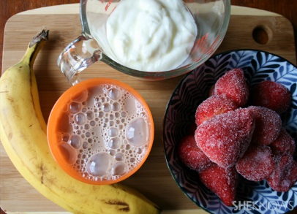

Ingredients:
- 1 frozen banana
- 2 cups frozen strawberries
- 3/4 cup plain Greek yogurt
- 1 cup low-fat chocolate milk

Berry Blast Smoothie
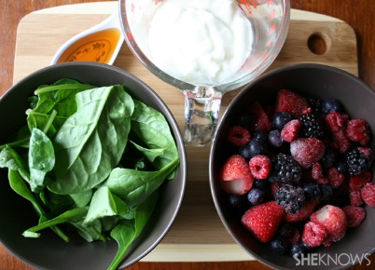

Ingredients:
- 2 cups loosely packed baby spinach (about two handfuls)
- 2 cups frozen mixed berries (I used strawberries, raspberries, blackberries, cherries and blueberries)
- 1 cup plain Greek yogurt
- 1 cup low-fat milk (soy, almond or coconut milk will work too)
- 1 tablespoon honey

