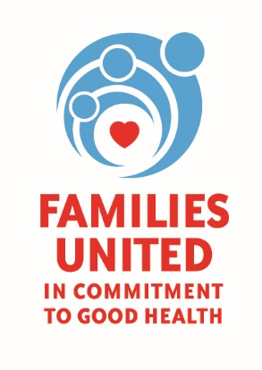

High Blood Pressure Faith and Healthy Lifestyle
Celebrating Families Day!
Families United: In Commitment To Good Health
Saturday, March 17, 2017 from 10:00 am – 3:00 pm

Asbury First United Methodist Church
1050 East Avenue | Rochester, NY 14607

VENDOR PARTICIPANT FORM

Name of Organization:

Type of service/organization:

Contact Person:
Name:
Email:
Office Number:
Cell Number:
Are you:

Adult Focused:

Youth Focused:

Vendor tables are FREE but please provide a door prize for a raffle.

Email form to Natosche Holt Natosche@gmail.com
Contact Mona Isler 727-7736 with questions.

Thank you!

