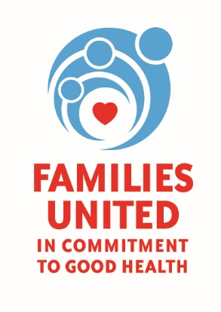

February 7, 2018

Dear Community Partner,

Twelve churches in the Rochester Community are participating in the Healthy Blood Pressure: Faith and Healthy Lifestyle Project through Common Ground Health. The participating churches are collaborating to plan a family health day that we hope will inspire, promote and adopt healthy lifestyle practices in their homes.

We cordially invite you to be a part of the High Blood Pressure Faith and Healthy Lifestyle
Celebrating Families Day! FAMILIES UNITED: IN COMMITMENT TO GOOD HEALTH by signing up for a FREE vendor table (tables are FREE but please provide a door prize for a raffle). Please complete the attached form and email to Natosche@gmail.com. (We have limited space so please respond quickly!)

High Blood Pressure Faith and Healthy Lifestyle Celebrating Families Day
Saturday, March 17, 2018
10:00 am – 3:00 PM
Asbury First United Methodist Church
1050 East Avenue
Rochester, NY 14607

Please contact Mona at 585-727-7736 if you have any questions.

Thank you,

Natosche Holt and Mona Isler
Vendor Committee
High Blood Pressure Faith and Healthy Lifestyle Celebrating Families Day

