A delicious and healthy (no white flour or butter, plus lower sugar) applesauce spice cake with an optional simple cream cheese frosting.

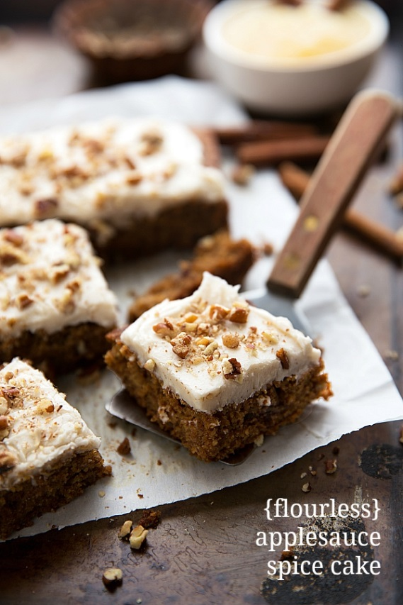
Prep time: 10 mins
Cook time: 30 mins
Serves: 1 8 x 8 baking pan

Ingredients
1 cup applesauce
1/4 cup coconut oil*
1 large egg
1/2 teaspoon vanilla extract
1 teaspoon baking soda
3/4 teaspoon cinnamon
1/4 teaspoon baking powder
1/4 teaspoon salt
1/4 teaspoon allspice
1/8 teaspoon nutmeg
1 cup oat flour (blend regular oats)
1/2 cup lightly packed brown sugar
1/4 cup chopped pecans or walnuts, optional
1/3 cup raisins, optional

Optional Cream Cheese Frosting
2 ounces reduced-fat cream cheese, at room temperature
1/2 teaspoon vanilla extract
Pinch of salt
1 and 1/4-3/4 cup powdered sugar
Optional: additional chopped pecans to top

Instructions
Preheat the oven to 350 degrees F. Line an 8 x 8 baking pan with parchment paper or butter/light flour.

In a large bowl, stir together the applesauce, coconut oil (measured when completely melted), large egg, and vanilla extract. Stir until completely combined.

Add in the baking soda, cinnamon, baking powder, salt, allspice, and nutmeg. Stir until completely combined. (Here's where you can increase or decrease spices to personal preference -- if you are wary of too much spice add a little less and if you LOVE spice increase them.)

Stir in the brown sugar and oat flour (blend regular old fashioned oats or quick oats in a blender or food processor until they resemble flour -- blend well so you don't have any weird oat chunks! Measure AFTER blending and not before).

If desired add in the chopped pecans or walnuts or raisins.

Bake for 30-35 mins at 350 degrees or until a fork when inserted comes out clean. Be careful to not over bake as it will make this cake less tender and less flavorful. Allow to cool.

Optional Cream Cheese Frosting:
In a mixing bowl place the *room temperature* cream cheese (Make sure it isn't melted or softened by the microwave). Beat with the vanilla until smooth. Add in the salt and slowly add in the powdered sugar (beating in between additions) until smooth and creamy and your desired consistency has been met. If it is too thick add in a little bit of milk or heavy cream.

Frost the completely cooled cake evenly with the frosting. If desired top the frosting with the chopped pecans.

Nutritional Information (2”x2” slice)
 | Calories | Carbs | Fat | Protein | Sodium | Sugar
Total | 1998 | 311 | 78 | 32 | 1416 | 132
Serving | 125 | 19 | 5 | 2 | 89 | 8

